Player Profile: Raphael Levy
Gary Wise
Different players are motivated in different ways. Some just want to own all the cards; some seek friendship through tournament play; and some see the game-any game-as a way to conquest and triumph. Raphael Levy is the latter.
"I started playing the game when I was twelve," Levy said, "and for me, the entire thing was about winning. At the time, I had played a lot of chess, and I couldn't end a session without winning the last game. So Magic gave me something new to win." And win he did.

"I always wanted to be the best."
Levy took an extreme amount of pleasure from beating players twice his age. Starting out with a preference for direct damage and Shivan Dragons, the diminutive twelve year old started beating adults almost immediately. Within a couple of years, the Toulouse, France, native was playing in Pro Tour Qualifiers, winning his third to qualify for Pro Tour-Atlanta.
Levy, who will be entering school this year as a language major specializing in Spanish and English, really started making noise at his fourth Tour event, Pro Tour-Mainz. By this point, Levy had joined Team Legion, an internet-based team of international players, and it had apparently helped. Feeling the pressure of being on a team of established pro players with only one Pro Tour event to his credit, he knew he had to take extreme measures to qualify. He took a night train to Dijon, which was 750 km from home, won a Qualifier, and went on to finish 12th at Mainz. Levy further established himself as an international star that year with his win at Grand Prix-Lyon.
Levy's crowning achievement came a year later at the 1998 World Championships. By this point, at age seventeen, Levy had a Grand Prix win and a strong Pro Tour performance on his résumé, but he was still a bit of an unknown. France was suffering a long drought win regards to Top 8 finishes, so Levy's breakthrough came at the right time.
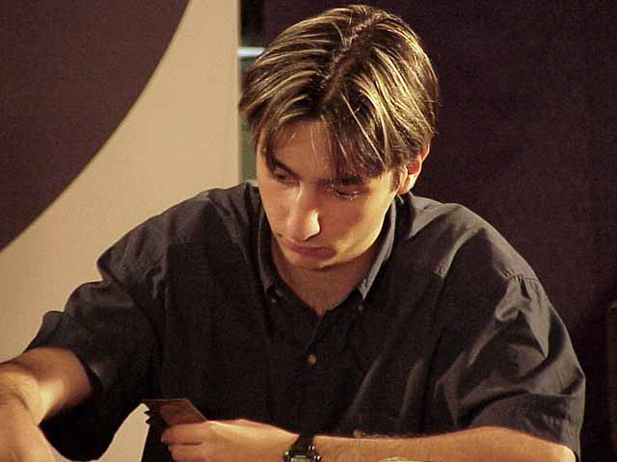
Playing "Recurring Nightmare" decks in both Block and Standard, Levy was at or near the top of the standings for the entire tournament, eventually finishing fourth. Suddenly, he wasn't the unknown kid with the thirst for dominance. Instead, he was now a Pro Tour star and was suddenly being heralded at France's best player. It was the answer to a dream. "I always wanted to be the best; that's really what has inspired me. Whenever I was ready to quit, I'd just remember I hadn't reached my goal and I would keep on going," Levy said.
Finally receiving the recognition he'd been searching for, Levy became one of the most feared players on the Tour. Although the 1998-1999 season was a relatively disappointing one for him, he followed it with his best year. In the 1999-2000 season, Levy managed a 17th-place finish in London and his second Pro Tour Top 8, when he finished fourth in Chicago. Levy capped off the year with a 15th-place finish at the World Championships in Brussels.
While the Pro Tour has obviously been his stomping grounds for some time now, with twenty-one Tour appearances to his credit, Levy really seems to shine at European events. In addition to his victory at Lyon, Levy finished fourth at 1999 Grand Prix-Barcelona and third at this year's Grand Prix-Göteberg. Additionally, Levy has always been tough at the European Championship, losing in the semifinals to eventual winner Nico Herzog in 1999 before losing to Noah Boeken in the finals in 2000. This year, Levy didn't make the Top 8, but he was in the running until the end.
Unfortunately, at the ripe old age of nineteen, Levy may be on the downswing of his career. "With maturity, I've lost that childish need to win, so some of the hunger is gone," said Levy. Recently, seeing that his life had reached a holding pattern in the Magic game and in his other pursuits, Levy dropped out of his math/computer studies and the Pro Tour to make a spiritual trip to Israel. "I think the trip helped put things back into perspective and may have reinstilled that need to win for me," he said, "so I think that I'll still be on the Tour for a while. The trip was really about finding some of my lost confidence. I was always very strong with how I approached a game and felt I couldn't lose, but recently that confidence was gone. And instead of not making mistakes, I would think about the mistakes I could potentially make. That's probably why I lost to Nico in 1999."
With his confidence back, Levy has started seeing better results, with his Top 8 finish in Göteberg a "real relief." Levy's 2000-2001 season has been a very solid one, as he has finished in the double digits of all four Pro Tour stops he's played at leading up to the World Championships.
So what does the future hold for "France's best player"? "I think that with my confidence returned, I won't be falling off the gravy train any time soon," he said. Working with such luminaries as Olivier and Antoine Ruel, Fred Courtois, and Pro Tour-New York teammates Franck Canu and Wilfried Ranque, Levy will continue to thrive on the Pro Tour, which he feels has a lot of growth ahead of it. Hopefully, he'll be right. But regardless, he'll still be there, proving he's the best and winning the last game.

